Call options provide the holder the right (but not the obligation) to purchase an underlying asset at a specified price (the strike price), for a certain period of time. If the stock fails to meet the strike price before the expiration date, the option expires and becomes worthless. Investors buy calls when they think the share price of the underlying security will rise or sell a call if they think it will fall. Selling an option is also referred to as ''writing'' an option.

Put options give the holder the right to sell an underlying asset at a specified price (the strike price). The seller (or writer) of the put option is obligated to buy the stock at the strike price. Put options can be exercised at any time before the option expires. Investors buy puts if they think the share price of the underlying stock will fall, or sell one if they think it will rise. Put buyers - those who hold a "long" - put are either speculative buyers looking for leverage or "insurance" buyers who want to protect their long positions in a stock for the period of time covered by the option. Put sellers hold a "short" expecting the market to move upward (or at least stay stable) A worst-case scenario for a put seller is a downward market turn. The maximum profit is limited to the put premium received and is achieved when the price of the underlyer is at or above the option's strike price at expiration. The maximum loss is unlimited for an uncovered put writer.

To obtain these rights, the buyer must pay an option premium (price). This is the amount of cash the buyer pays the seller to obtain the right that the option is granting them. The premium is paid when the contract is initiated.

What is a 'Straddle'

A straddle is an options strategy in which the investor holds a position in both a call and put with the same strike price and expiration date, paying both premiums. This strategy allows the investor to make a profit regardless of whether the price of the security goes up or down, assuming the stock price changes somewhat significantly.

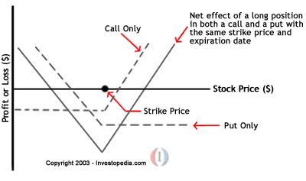

The profit when the price of the underlying asset is increasing is given by:

Profit(up) = Price of the underlying asset - the strike price of the call option - net premium paid

The profit when the price of the underlying asset is decreasing is given by:

Profit(down) = Strike price of put option - price of the underlying asset - net premium paid

A company issues an option for the right to buy their stock. An investor buys this option and hopes the stock goes higher so their option will increase in value.

Theoretical option price = (current price + theoretical time/volatility premium) – strike price

Let's look at an actual example, PNC options for January 2012:

* [Strike price](https://en.wikipedia.org/wiki/Strike_price) – the price the investor can buy the stock at through the option.
* Symbol – like a stock symbol but for options it incorporates the date.
* Last – like the last stock price, it is the last price traded between two parties.
* Change – how much it went up and down today.
* Bid – what a person is bidding for the option.
* Ask – what someone wants to sell the option for.
* Vol – how many options traded today.
* Open Int – how many options are available, i.e. the option float